Test Cases & Results for ROS2 as middleware

* **Module Definition**
  + Data node
    - D1: Image node
      * PS: Publish the 1920*1080pixels / 60fps image stream **a**
      * Service: Start/Stop
    - D2: Image Process node
      * PS: Subscribe image stream **a**
      * PS: Publish Status String **b** /Result String **c**
      * Service: Start/Stop/Image Process Rate(control the resources of processing)
    - D3: Result Convert node
      * PS: Subscribe Result String **c**
      * OUTPUT: UDP package **d**
  + Log node
    - L1: Passive Log node
      * PS: Subscribe Status String **b**
      * PS: Publish log **e**
    - L2: Active Log node
      * Action: Push log **f** alternatively
    - L3: Log Convert node
      * PS: Subscribe log **e** / **f**
      * OUTPUT: UDP package **g**
  + Script
    - S1: A launch script for system
      * Launch D1->D2->D3
      * Launch L1, L2, L3
    - S2: A stop script for system

Test cases for developers

Stability and Robustness

* **Case 1: Single Long Time Run**
  + Image Process Rate to be set to 1.0
  + Launching S1, to run the system for **x** hours
  + Checking stuck/crashing status
* **Standard 1:** **x** should be larger than 24 without system crashing/stuck
* **Test Steps:**

Run the following nodes in order.

①ros2 run py_pubsub image_source_video (D1py)

②ros2 run test_pkg D2cpp

③ros2 run test_pkg D3cpp

④ros2 run test_pkg L1

⑥ros2 run test_pkg L2

⑦ros2 run test_pkg L3

⑧ros2 run test_pkg talker / ros2 run test_pkg listener

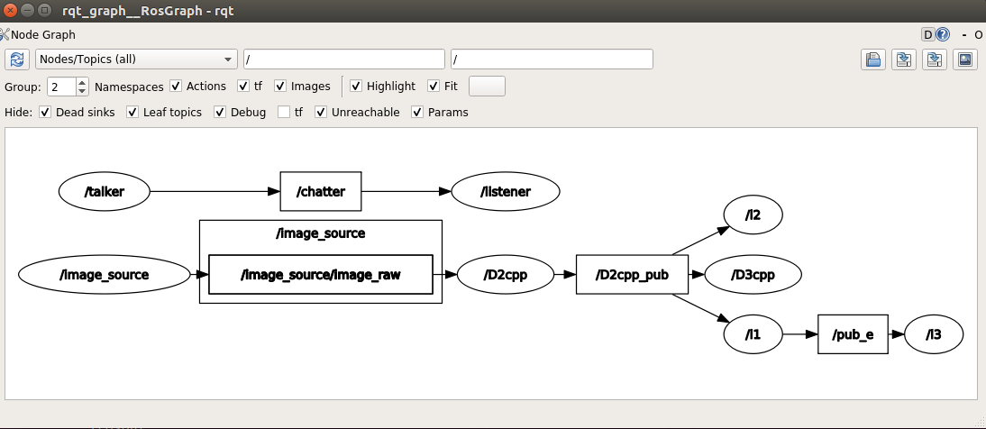

Figure 1. rqt_graph

-  **Results:**

Time of running: **93725 seconds**; Crashing Error: **0;** Stuck Error: **0**

①The node network is still communicating normally, and there is no crashed node and the talker and listener still work well;

②At **93890s**, through instruction `**ros2 topic echo “/D2cpp_pub” (“/pub_e /chatter …”)`**, The data shows correctly and normally.

Through the rviz2, we can see that the topic of “/image_source_raw” and the video stream still runs well.

* **Case 2: Loop Long Time Run**
  + Image Process Rate to be set to 1.0
  + Launching S1, to run the system for **x** hours
  + Launching S2, then launching S1, looping for **y** times
  + Checking stuck/crashing status
* **Standard 2:** **y** should be larger than 1000 without system crashing/stuck
* **Test Steps:**

① Use a shell script to automatically launch S1 (to start all nodes) and S2 (to stop all nodes). Command: `./test_s1_s2.sh

* **Results:**

Cycles: **1200 times**; Crashing Error: **0**; Stuck Error: **0**

①The node network is still communicating normally, and there is no crashed node. The talker and listener still works well.

* **Case 3: Broken Run**
  + Image Process Rate to be set to 1.0
  + Launching S1, to run the system for **x1** hours
  + Killing Middleware service for **y** times
    - kill L1/L2, check output of string **c**
    - kill D3, check L1/L2 log
  + Checking stuck/crashing status and measuring this period as **x2** hours
* **Standard 3:** **x2** should be larger than 0.25 without system crashing/stuck
* **Test Steps:**

Run the following nodes in order:

①ros2 run py_pubsub image_source_video (D1py)

②ros2 run test_pkg D2cpp

③ros2 run test_pkg D3cpp **(will be killed later...)**

④ros2 run test_pkg L1

⑥ros2 run test_pkg L2 **(will be killed later...)**

⑦ros2 run test_pkg L3

⑧ros2 run test_pkg talker / ros2 run test_pkg listener

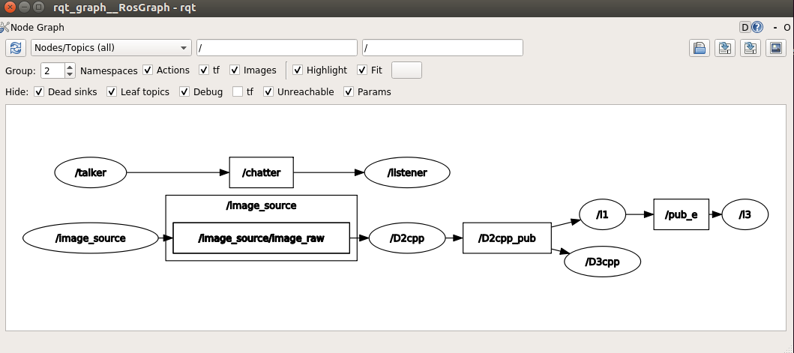

Figure 2. killing L2 node, rqt_graph

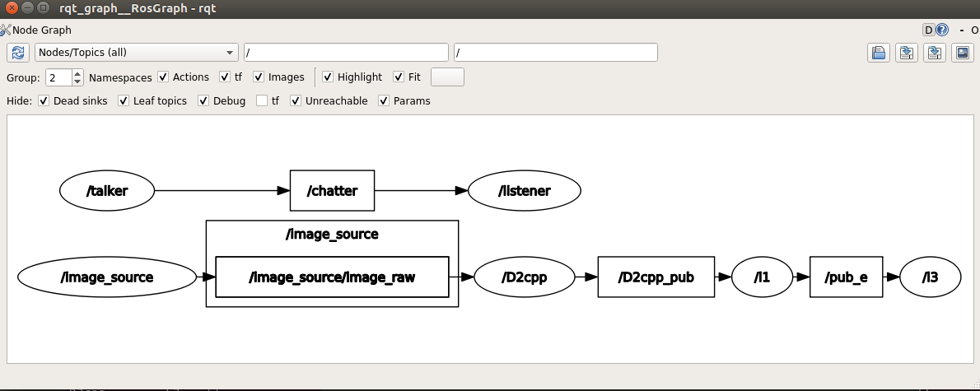

Figure 3. killing L2&D3 node, rqt_graph

* **Results:**

Time of running: **1** hours; Crashing Error: **0**; Stuck Error: **0**

①Kill the node L2, and wait for about 0.3 hours, then restart the L2. Re-establishment of communication between nodes happened;

②Kill the node D3, and wait for about 0.3 hours, then restart the D3. Re-establishment of communication between nodes happened.

System Resource

* **Case 4: Low Resource Run**
  + Image Process Rate to be set to **k** * 1.0, making the CPU occupancy rate **r1** / GPU occupancy rate **r2**
  + Launching S1, to run the system for **x** hours
  + Checking stuck/crashing status
* **Standard 4:** when **r1**/**r2** is larger than 80%, **x** should be larger than 1 without system crashing/stuck
* **Test Steps:**

run the following nodes in order:

①ros2 run py_pubsub image_source_video (D1py)

**②ros2 run test_pkg client_rateChange**

**(which makes the image process rate change according to k*1.0)**

**③ros2 run test_pkg client_time**

**(which makes the CPU occupancy rate change dynamically from 1-8 CPU utilization processes every hour)**

* **Note:**

**Use command `cat /proc/cpuinfo | grep 'processor' |wc -l` to check the status of CPUs**



**Figure 4. the number of cpu to occupy**

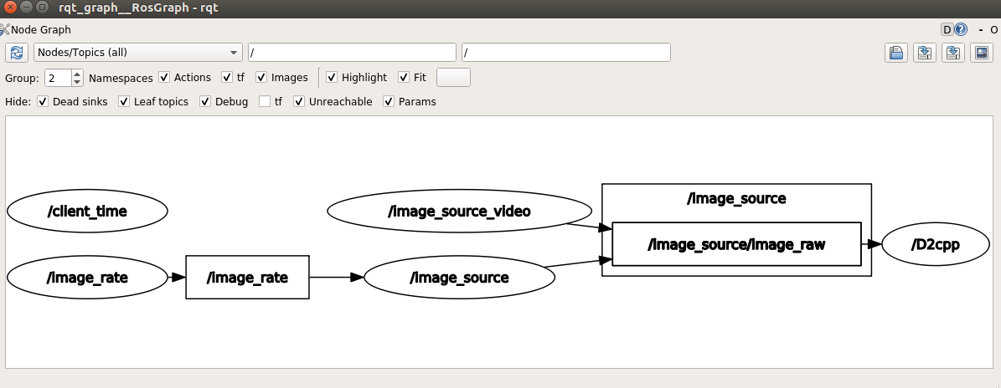

**Figure 5.Low Resource Run rqt_graph**

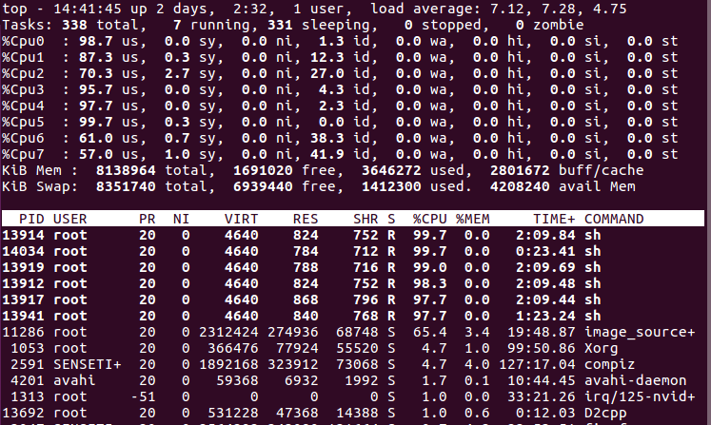**Figure 6.cpu processes usage (6/8)**

* **Results:**

**Time of running: 18825 seconds; Error: 0; Warning: 0**

①The node network is still communicating normally, and there is no crashed node. The talker and listener still works well;

②At **18890s**, Through the rviz2, we saw that the topic of“/image_source_raw”and the video stream was still running well;

③Through command `**ros2 run test_pkg client_time`** thatpublished clients to control CPU rate, in case of high CPU usage **(5-8** **CPU utilization processes),** all of nodes still work well.

* **Case 5: High Concurrency Run**
  + Duplicating D1->D2->D3 for **y1** times, marking the CPU occupancy rate **r1** / GPU occupancy rate **r2**
  + Launching S1, to run the system
  + Measuring the publisher and subscriber I/O operations per second as **y2**
  + Checking stuck/crashing status
* **Standard 5:** when **r1**/**r2** is larger than 80%, **y1** should be larger than 8, **y2** should be larger than () without system crashing/stuck
* **Test Steps:**

Run the following nodes in order.

①ros2 run py_pubsub image_source_video (D1py)

②ros2 run test_pkg D2cpp

③ros2 run test_pkg D3cpp

④ros2 run test_pkg L1

⑥ros2 run test_pkg L2

⑦ros2 run test_pkg L3

⑧ros2 run test_pkg talker　ros2 run test_pkg listener

⑨**ros2 run test_pkg client_time**

**(which makes the CPU occupancy rate change dynamically from 1-8 CPU utilization processes every half an hour)**

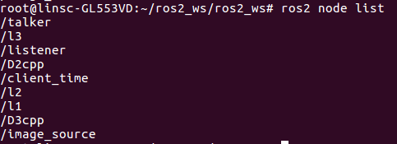

**Figure 7.ros2 node list**

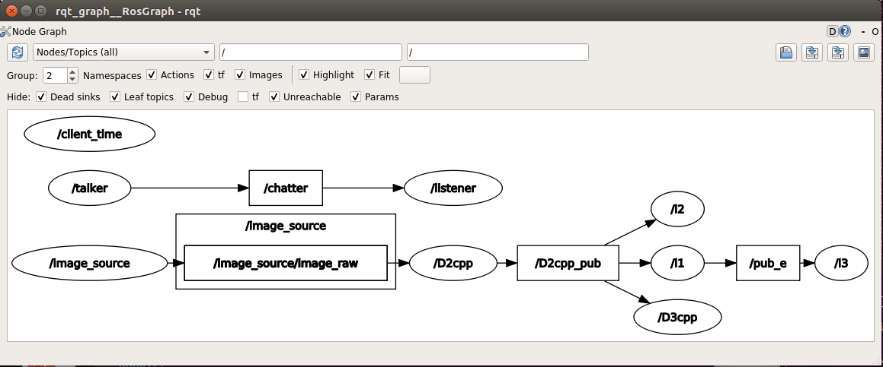**Figure 8. High Concurrency rqt_graph**

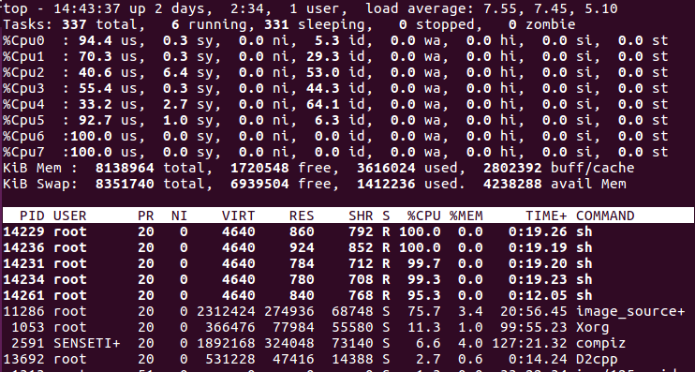

**Figure 9.cpu processes usage (５/8)**

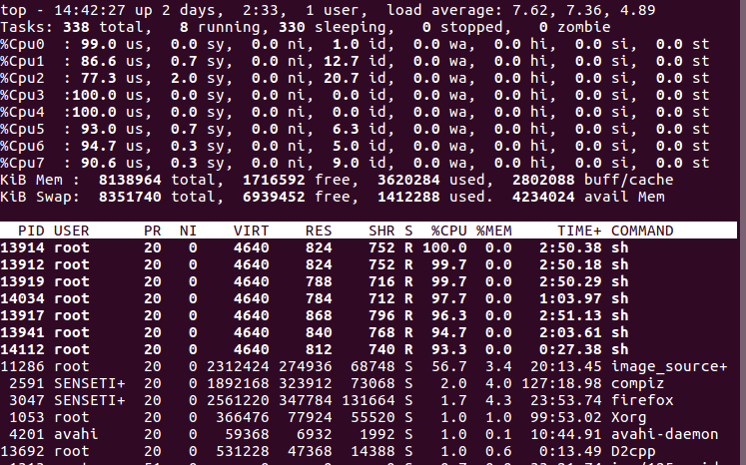

**Figure 10.cpu processes usage (７/8)**

**-**  **Results:**

**Time of running:** 93725 seconds; Error: 0; Warnings: **1**

①Look at Figure 9 and 10, the CPU processes usage changes from 5/8 to 7/8 which made the CPU utilization allocated to the node of image_source was reduced from 75.7% to 56.7%, and to the node of D2cpp was reduced from 2.7% to 1.0%.

②The node network is still communicating normally, and there is no crashed node and the talker and listener still worked well;

③At 93890s, through command `**ros2 topic echo “/D2cpp_pub” (“/pub_e /chatter …”)`**, the data showed correctly and normally.

Through the rviz2, we saw that the topic of “/image_source_raw”and the video stream was still running well;

④ At 93932s, running command `**ros2 run test_pkg client 0 1(2,3,4….) `** to publish clients that changed the number of CPU rate, it can still deliver messages normally and work well.

⑤At about > 93725 seconds, there was a warning showing. **The warning was from “ros2 run test_pkg** **client_time”, but it did not affect the normal communication of the network**. Restarting this node can solve this.

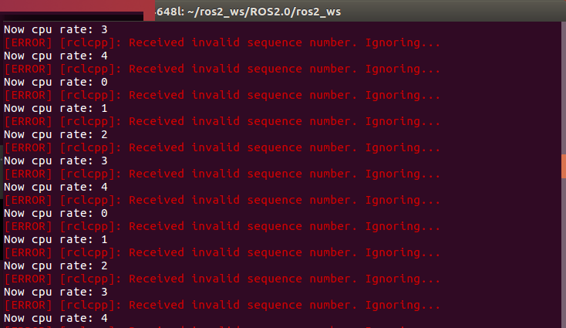

**Figure 11.The node “ client_time” warning**

Test cases for user experience

Eligibility

* **Case 6: Low Latency Run**
  + Image Process Rate to be set to 1.0
  + Launching S1, to run the system for **x** hours
  + Measuring the system latency from D1 to D3 as **y** ms
* **Standard 6:** **y** should be less than 30

- **Test Steps:**

Run the following nodes in order.

①ros2 run py_pubsub image_source_video (D1py)

②ros2 run test_pkg D2cpp

③ros2 run test_pkg D3cpp

**- Result:**

Time of running: 10 min; Error: 0; Warnings:**0**

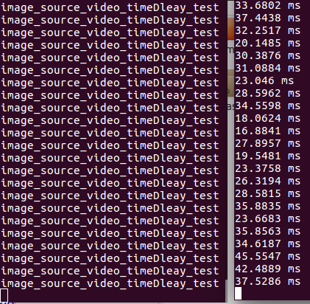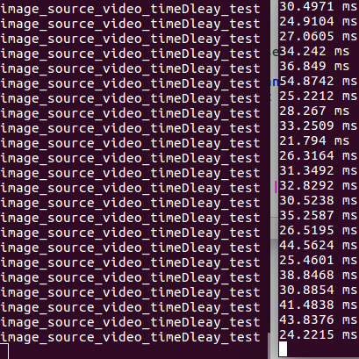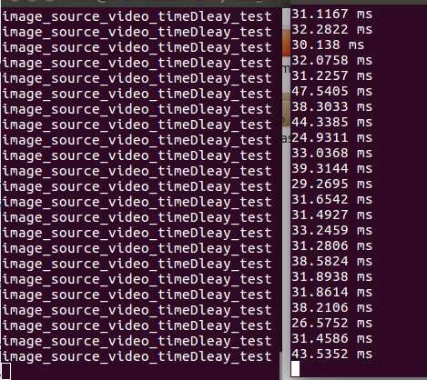

**Figure 12.The node “Image_source_video” Latency test**

①From Figure 12, the average latency of the node “image_source_video” was about 30 ms.

Usability

* **Case 7: Interruption Run**
  + Image Process Rate to be set to 1.0
  + Launching S1, to run the system for **x** hours
  + Call Service of S1/S2 for **y** times within one reaction period
  + Checking stuck/crashing status
* **Standard 7:** when **y** is larger than 2, system should not be crashing/stuck
* **Test Steps:**

Run the following nodes in order.

①ros2 run py_pubsub image_source_video (D1py)

②ros2 run test_pkg D2cpp

③ros2 run test_pkg D3cpp

④ros2 run test_pkg L1

⑥ros2 run test_pkg L2（Push log **f** alternatively）

⑦ros2 run test_pkg L3 (Accept)

⑧ros2 run test_pkg talker / ros2 run test_pkg listener

⑨**ros2 run test_pkg client_time**

**(which makes the CPU occupancy rate change dynamically from 1-8 CPU utilization processes every second)**

**- Result:**

**Time of running: 12528** **seconds; Error:0; Warning:0**

①The node network was still communicating normally, and there was no crashed node and the talker and listener still worked well.

* **Case 8: Data frame loss test**

|  |  |  |  |  |
| --- | --- | --- | --- | --- |
| Msg : **“Hello LinSC666! Test wheather LosingData...msg->data”+int[num]**  The number of Msg: **1,000,000**  CPU processes usage: **6/8 && 1/8** | | | | |
|  | Sending Frequency | | | |
| 100Hz | 500Hz | 1KHz | 10KHz |
| Number of dropped frames | 999982/1000000  (miss 18) | 999936/1000000  (miss 64) | 999896/1000000  (miss 104) | 571209/1000000  (miss 428791) |
| 998973/1000000  (Low CPU processes usage: **1/8**,miss **1027**) |

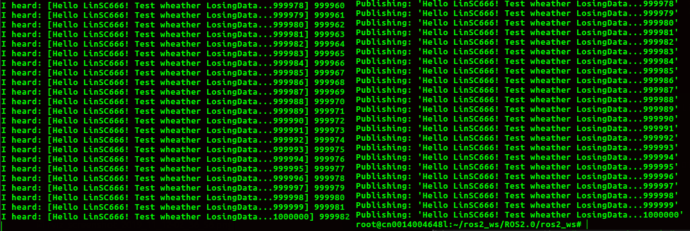 **Figure 13.Number of dropped frames under 100Hz****,6/8 cpu usage**

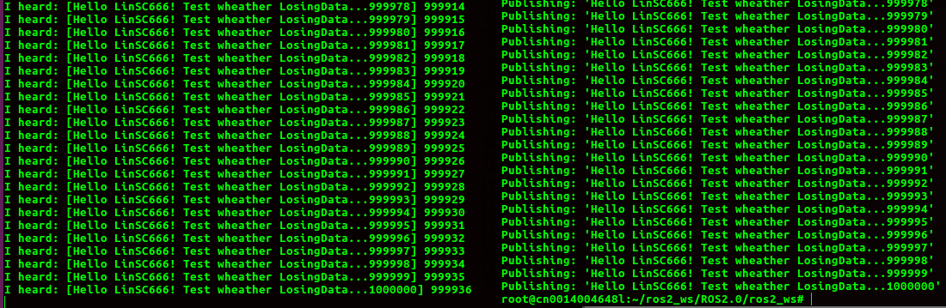 **Figure 14.Number of dropped frames under 500Hz,6/8 cpu usage**

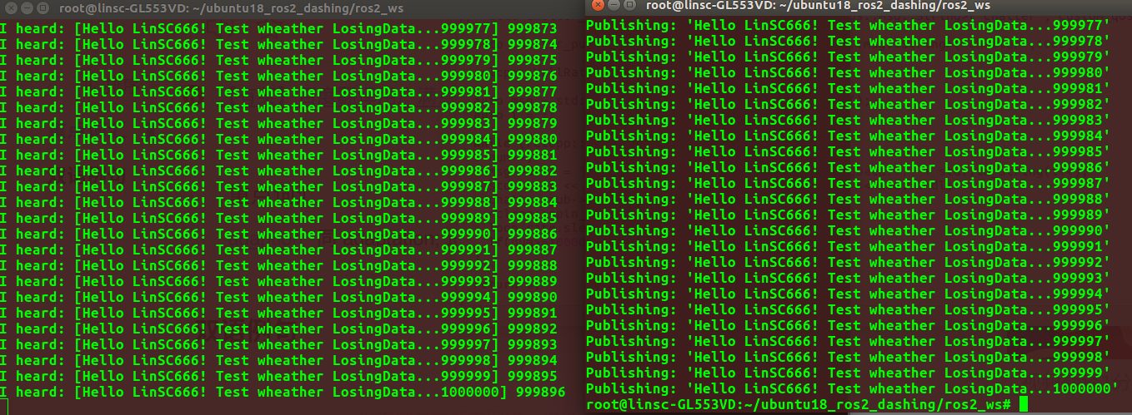**Figure 15.Number of dropped frames under 1KHz,6/8 cpu usage**

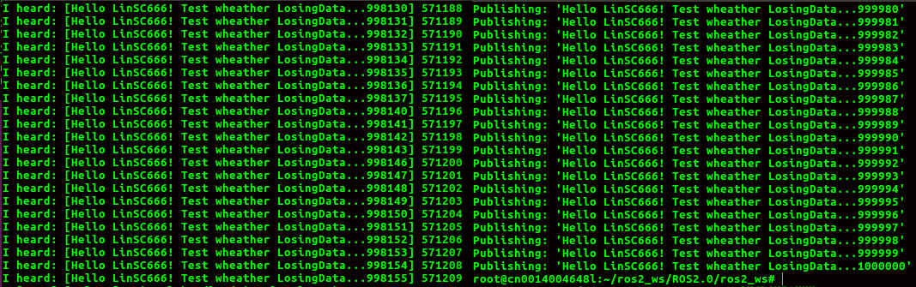**Figure 16.Number of dropped frames under 10KHz,6/8 cpu usage（ serious data lost)**

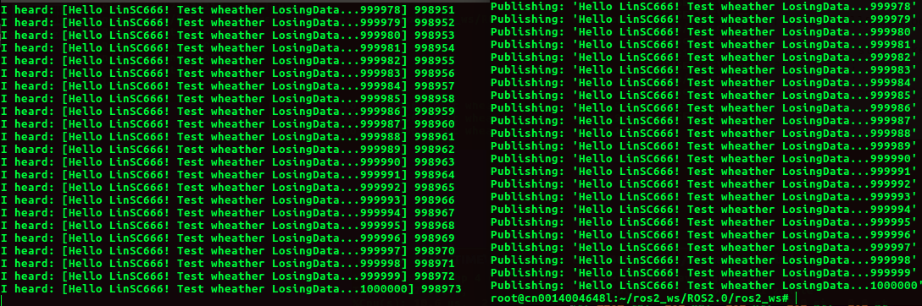**Figure 17.Number of dropped frames under 10KHz,1/8 cpu usage**

**- Result:**

**①under CPU processes usage= 6/8，when Sending Frequency <=1KHz, it will lose little some data frame.**

**②under CPU processes usage= 6/8,when Sending Frequency >=10KHz, it lost a lot of data frames,and it occurred serious data lost.But it showed good under CPU processes usage= 1/8.**

|  |  |  |  |
| --- | --- | --- | --- |
| Topic : **“image_source/image_raw”**  The number of Frame_id: **1,000,000**  Picture resolution : **980 * 720**  CPU processes usage: **6/8 && 1/8** | | | |
|  | Sending Frequency | | |
| **100Hz** | **500Hz** | **1KHz** |
| Number of dropped frames | 999976/1000000  (high CPU processes usage: **6/8**,miss **24**) | 997248/1000000  (high CPU processes usage: **6/8**,miss **2752**) | 992400/1000000  (high CPU processes usage: **6/8**,miss **7600**) |
| 997968/1000000  (Low CPU processes usage: **1/8**,miss **2032**) |

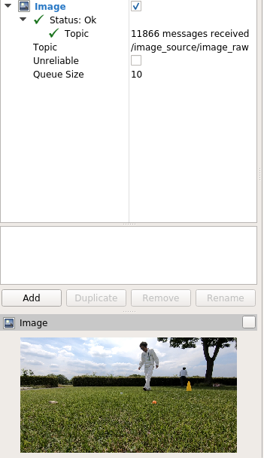

**Figure 18.The Received Image show**

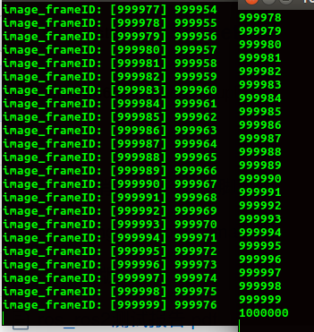

**Figure 19.Number of dropped image_frames under 100Hz,6/8 cpu usage**

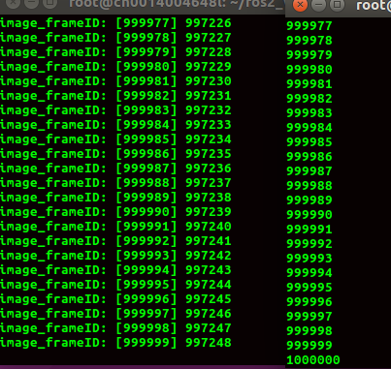

**Figure 20.Number of dropped image_frames under 500Hz,6/8 cpu usage**

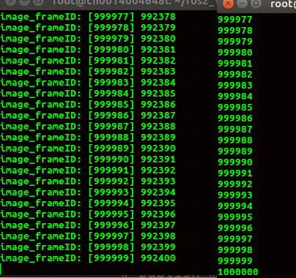

**Figure 21.Number of dropped image_frames under 1KHz,6/8 cpu usage**

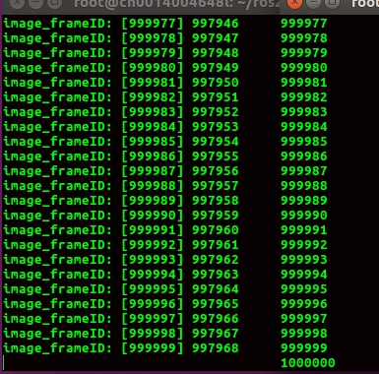

**Figure 22.Number of dropped image_frames under 1KHz,1/8 cpu usage**

**- Result:**

**①Each image resolution was 980*720, under CPU processes usage= 6/8，when Sending Frequency <=100Hz, it will lose little some image frame.**

**②under CPU processes usage= 6/8,when Sending Frequency >=500Hz, it lost a lot of image frames,and it occurred serious data lost.But it showed good under CPU processes usage= 1/8.**